Operating Systems Project #1 Report

Q1.

In this question, we’ve been asked to write a shell script that takes an input file contains numbers and prints asterisks according to given input numbers. So, to do that, we created a variable named filename and assigned it to the input file. While reading the input file line by line, we designed a for loop that contains a counter variable which is equal to data in the current line. We searched and found that when we use echo with –ne extension, it prints any input between double quotes at the same line. After this, to continue from next line, we printed an asterisk using echo without –ne. Also, we paid attention to not to write extra asterisks when we pass to the next line. To prevent this, we ended our for loop when counter is greater than one.

This is our input file :

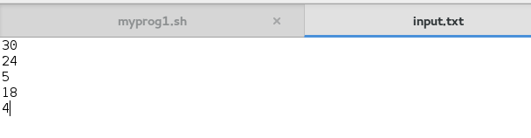

And this is the output:

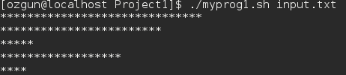

Q2.

In this question, we’ve been asked to write a shell script that takes a path which we want to write path list a file and delete file which user want to delete. So, we needed to get path from user. After we got path, we print path file contents to a file in work space directory which name is file.txt. After this operation we created a while loop for reading line by line. Then, script ask user to delete file or not. If user press “y” or “Y” , the file will be deleted. If user press “n” or “N” file will not be deleted.

This is how we start to program. We gave a path.



Input and output.

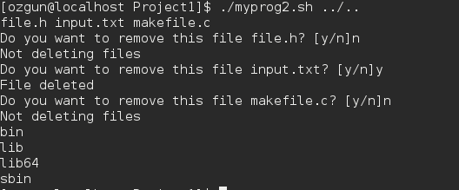

Q3.

In this question, we changed a word which user want to change with another word. We took an input file which extension is .txt, contains texts. So, at the begining we gave file name which extension is .txt and executed the program. If the file does not exist , the program will be give a message to user and it will exit from program. If file exist, the program will take a word (old word) which user want to replace with new word. So, we took two inputs while program is running. After these operations , we used for loop to find word which user want to change. If we find to word , we replace it with another one.

This is how we start to program. We gave a file name.

C:\Users\asusnb\AppData\Local\Microsoft\Windows\INetCache\Content.Word\3.png

Input and output.

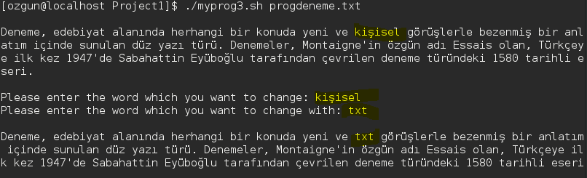

Q4.

In this question, we tried to find to largest and smallest file in the current directory and send these two files to Largest and Smallest directory . We did not get any paramatre at the begining. Firstly, we create smallest and largest directory. Secondly, we find largest and smallest files in the current directory by using find commad. After this operation, We gave message to user which file is largest and smallest. Lastly, we moved largest file to largest directory and smallest file to smallest directory

Input and output

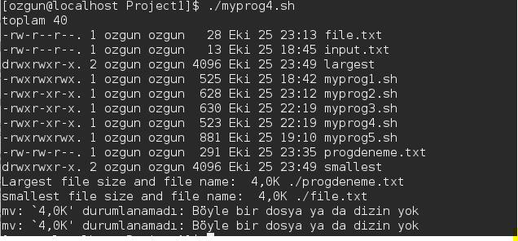

After runned program, two directories were created.

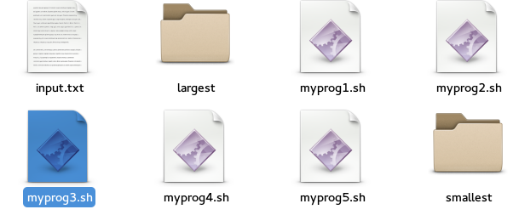.

Largest directory. Largest file moved to largest directory.

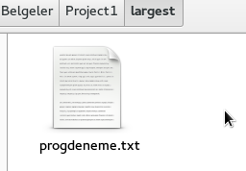

Smallest directory. Smallest file moved to smallest directory.

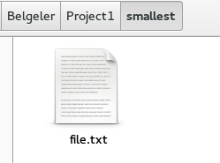

Q5.

In this question, we’ve been asked to write a shell script that takes a number as an argument and should calculate the sum of numbers formed by exchanging consecutive digits. To do this, firstly we defined a variable named length that keeps the length of input integer. After that, we created an input variable and assigned it to our input. We created an index variable that keeps the index of last digit. Lastly, we created a total variable to calculate the mathematical problem. We calculated the mathematical value of it and came with this equality: The sum that wanted from us is equal to 1 time first digit plus 11 times middle digits plus 10 times last digit. We made a for loop and lasted it at the size of length and in this for loop we calculated the equation above. If index number is 0, it adds 1 time first digit to total. Else if index number equals to middle digits, it adds 11 times middle digits to total and if it equals to index of last digit, it adds 10 times last digit to total and prints total after for loop.

Here is the input and output of our code:

